# CERTIFICATE

This is to certify that the internship report is done by **K. SIVARAMAN (Reg No:232535)** in partial fulfillment of the requirement for the award of degree of M.Sc., Computer Science (2023-2025) is the original work done by the candidate under my guidance and submitted to Bharathidasan University, Trichy, through **Government Arts College (Autonomous), Karur-5.**

### Signature of the HOD Signature of the Mentor

Submitted for the Viva-Voce Examination held on

**Signature of the Internal Examiner Signature of the External Examiner**

# COMPANY CERTIFICATE

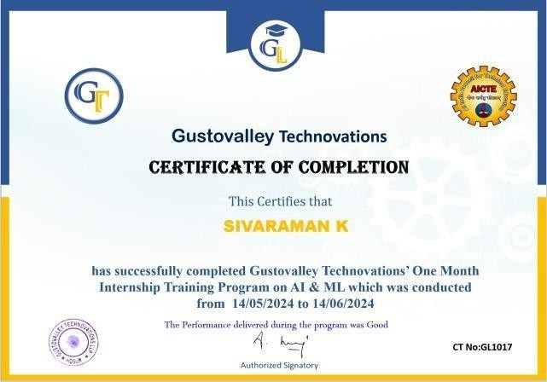

## DECLARATION

I am **K. SIVARAMAN** do here by declare that the Internship work has been under taken by me as part of my studies in the degree M.Sc., Computer Science. I have completed this work under the guidance of **Dr. C. JAYANTHI,** Associate professor, PG & Research Department of Computer Science, Government Arts College (Autonomous) Karur-5 and **GUSTOVALLY TECHNOVATIONS** .

I also declare that this work has not been submitted for the award of any degree, diploma, associateship or fellowship or any other in this University or any other University.

**K. SIVARAMAN**

## ACKNOWLEDGEMENT

I am indebted to many people who helped me to accomplish this internship successfully.

I thank **Dr. S. ALEXANDER M.A., M.Phil., Ph.D.**, Principal for granting permission to undertake this internship program.

I thank **Dr. M. PRABAKARAN, M.Sc., M.Phil., Ph.D.,** Associate Professor & Head, PG & Research Department of Computer Science for the constant support in completing this internship program.

I thank **Dr. C. JAYANTHI M.Sc., M.Phil., Ph.D.,** Associate professor PG & Research Department of Computer science for her support and guidance during the course of my internship. I remember her with much gratitude for her patience and motivation.

I thank **GUSTOVALLY TECHNOVATIONS** for allowing me to undertake this internship program and supported me in gaining the knowledge to bridge the gap between the curriculum and the industry.

I thank my parents for their blessings and constant support, without which this internship would not have seen the light of day.

# INDEX

|  |  |  |
| --- | --- | --- |
| **S.No** | **CONTENTS** | **Page.No** |
| **1** | **Certificate** | **2** |
| **2** | **Company-Certificate** | **3** |
| **3** | **Declaration** | **4** |
| **4** | **Acknowledgement** | **5** |
| **5** | **Artificial Intelligence** | **7** |
| **6** | **Machine Learning** | **10** |
| **7** | **Python** | **14** |
| **8** | **Open CV** | **17** |
| **9** | **Python Basic Syntax and Examples** | **19** |
| **10** | **Conclusion** | **24** |
| **11** | **Appendix** | **25** |

**Summery of the Internship Introduction to Artificial Intelligence and Machine Learning Introduction to Artificial Intelligence (AI)**

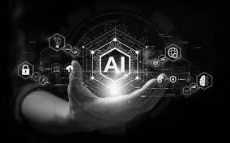

Artificial Intelligence (AI) is the simulation of human intelligence processes by machines, especially computer systems. These processes include learning (the acquisition of information and rules for using the information), reasoning (using rules to reach approximate or definite conclusions), and self-correction. AI applications include expert systems, natural language processing (NLP), speech recognition, and machine vision.

## AI Techniques

* Machine learning,
* Neural Networks,
* Deep Learning,
* Natural Language processing(NLP).

## Capabilities

### Narrow AI (Weak AI)

* + **Definition**: AI systems that are designed and trained for a specific task.
  + **Examples**: Siri, Alexa, recommendation systems, image recognition.
  + **Characteristics**: Limited scope, high performance in the defined task, but cannot

generalize to other tasks.

### General AI (Strong AI)

* + **Definition**: AI systems that possess the ability to understand, learn, and apply intelligence across a broad range of tasks at a human-like level.
  + **Examples**: As of now, this type of AI is hypothetical and has not yet been realized.
  + **Characteristics**: Flexible, autonomous, capable of generalizing knowledge and skills.

### Super AI

* + **Definition**: AI that surpasses human intelligence in all aspects, including creativity, problem-solving, and emotional intelligence.
  + **Examples**: Hypothetical future AI that is often depicted in science fiction.
  + **Characteristics**: Highly autonomous, potentially capable of self-improvement beyond human control.

## Applications

### Healthcare

* Examples: Diagnostic tools, personalized medicine, robotic surgeries, drug discovery.
* Impact: Improved accuracy in diagnosis, enhanced patient care, reduced costs.

### Finance

* Examples: Fraud detection, algorithmic trading, credit scoring, personalized banking.
* Impact: Enhanced security, better investment strategies, improved customer service.

### Automotive

* Examples: Autonomous vehicles, predictive maintenance, driver assistance systems.
* Impact: Increased safety, reduced traffic congestion, enhanced driving experience.

### Manufacturing

* Examples: Predictive maintenance, quality control, supply chain optimization.
* Impact: Increased efficiency, reduced downtime, enhanced product quality.

### Entertainment

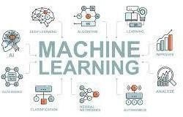

* Examples: Content recommendation, video game AI, music composition.
* Impact: Personalized content delivery, immersive gaming experiences, new creative tools.

### Education

* Examples: Intelligent tutoring systems, personalized learning, automated grading.
* Impact: Tailored education experiences, improved learning outcomes, reduced teacher workload.

## Introduction to Machine Learning (ML)

Machine Learning (ML) is a subset of AI that involves the use of algorithms and statistical models to enable computers to perform tasks without explicit instructions. It relies on patterns and inference instead. ML algorithms build a mathematical model based on sample data, known as "training data", to make predictions or decisions without being explicitly programmed to perform the task.

## Types of Machine Learning

Machine learning can be broadly categorized into three types based on the nature of the learning process:

### Supervised Learning

* + **Definition**: The algorithm learns from labeled data, where the input data is paired with the correct output.

#### Examples:

* + - **Regression**: Predicting a continuous value (e.g., predicting house prices).
    - **Classification**: Predicting a discrete label (e.g., spam detection in emails).
  + **Techniques**: Linear regression, logistic regression, support vector machines, neural networks, decision trees, random forests.

### Unsupervised Learning

* + **Definition**: The algorithm learns from unlabeled data, identifying patterns and relationships without predefined labels.

#### Examples

* + - **Clustering**: Grouping similar data points together (e.g., customer segmentation).
    - **Dimensionality Reduction**: Reducing the number of features while retaining important information (e.g., principal component analysis).
  + **Techniques**: K-means clustering, hierarchical clustering, DBSCAN, principal component analysis (PCA), t-distributed stochastic neighbor embedding (t-SNE).

### Reinforcement Learning

* + **Definition**: The algorithm learns by interacting with an environment, receiving feedback in the form of rewards or penalties, and optimizing its actions to maximize cumulative reward.

#### Examples

* + - **Game Playing**: Algorithms that learn to play games (e.g., AlphaGo, reinforcement learning in video games).
    - **Robotics**: Algorithms that control robotic actions to achieve specific goals.
  + **Techniques**: Q-learning, deep Q-networks (DQNs), policy gradients, actor-critic methods.

## Applications of Machine Learning

Machine learning has a wide range of applications across various industries

### Finance

* + **Examples**: Fraud detection, credit scoring, algorithmic trading.
  + **Impact**: Enhanced security, optimized investment strategies, better risk management.

### Marketing and Sales

* + **Examples**: Customer segmentation, recommendation systems, sentiment analysis.
  + **Impact**: Personalized marketing, increased sales, improved customer engagement.

### Transportation

* + **Examples**: Predictive maintenance, route optimization, autonomous vehicles.
  + **Impact**: Reduced maintenance costs, optimized logistics, safer transportation.

### Manufacturing

* + **Examples**: Quality control, predictive maintenance, supply chain optimization.
  + **Impact**: Increased efficiency, reduced downtime, enhanced product quality.

### Entertainment

* + **Examples**: Content recommendation, video game AI, music composition.
  + **Impact**: Personalized content delivery, immersive gaming experiences, new creative tools.

## Introduction to Python for AI and Machine Learning



**What is Python**

Python is a high-level, interpreted programming language known for its simplicity, readability, and versatility. Created by Guido van Rossum and first released in 1991, Python has become one of the most popular programming languages due to its ease of use and powerful libraries. It supports multiple programming paradigms, including procedural, object-oriented, and functional programming.

**Why Python for AI and ML** Python is the preferred language for AI and ML for several reasons **Ease of Learning and Use**

* Python's syntax is straightforward and readable, making it accessible to beginners and efficient for experienced programmers.

#### Rich Ecosystem of Libraries and Frameworks

* Python boasts a wide range of libraries and frameworks specifically designed for AI and ML, such as TensorFlow, Keras, PyTorch, Scikit-learn, and OpenCV.

#### Community Support

* Python has a large and active community, providing extensive documentation, tutorials, and forums for support.

#### Integration and Flexibility

* Python can easily integrate with other languages and tools, making it flexible for various applications and workflows.

## Python Libraries for AI and ML

### NumPy

* **Purpose**: Fundamental package for scientific computing with Python.
* **Features**: Provides support for arrays, matrices, and a collection of mathematical functions to operate on these data structures.

### Pandas

* **Purpose**: Data manipulation and analysis.
* **Features**: Offers data structures like DataFrame for handling tabular data, making it easier to preprocess and analyze datasets.

### PyTorch

* **Purpose**: Deep learning.
* **Features**: An open-source machine learning library based on the Torch library, used for applications such as computer vision and natural language processing.

### OpenCV

* **Purpose**: Computer vision.
* **Features**: Provides tools for real-time computer vision and image processing tasks.

## Introduction to OpenCV What is OpenCV

OpenCV (Open Source Computer Vision Library) is an open-source computer vision and machine learning software library. It contains over 2,500 optimized algorithms, which can be used to perform various computer vision tasks. OpenCV is designed for computational efficiency and is ideal for real-time applications. It was initially developed by Intel, and it supports a wide range of programming languages, including C++, Python, Java, and MATLAB.

## Why Use OpenCV

OpenCV is popular for several reasons

* **Extensive Library**: Provides a vast range of tools for image and video processing.
* **Performance**: Highly optimized for real-time applications.
* **Portability**: Runs on various platforms, including Windows, Linux, macOS, Android, and iOS.
* **Open Source**: Free to use and modify under the BSD license.
* **Community Support**: Large community contributing to and supporting the library.

## Key Features of OpenCV

### Image Processing

* + Basic operations like filtering, image transformations, and geometrical transformations.
  + Color space conversions and histograms.

### Video Analysis

* + Techniques such as object detection, background subtraction, and optical flow.

### Camera Calibration and 3D Reconstruction

* + Camera calibration, stereo vision, and 3D reconstruction from stereo images.

### Object Detection

* + Detection of objects using pre-trained models, including face detection using Haar cascades.

### Machine Learning

* + Built-in support for various machine learning algorithms, including SVM, k-NN, and decision trees.

### Deep Learning

* + Integration with deep learning frameworks like TensorFlow and Caffe.

## Python Basic Syntaxes and Examples

### Variables

* Integer variable

age = 25 print(f"Age: {age}")

* Float variable

price = 19.99 print(f"Price: {price}")

* String variable

name = "Alice" print(f"Name: {name}")

* Boolean variable

is_student = True

print(f"Is student: {is_student}")

* List

numbers = [1, 2, 3, 4, 5] print(f"Numbers: {numbers}")

* Dictionary

person = { "name": "Alice", "age": 25, "is_student": True }

print(f"Person: {person}")

* Tuple

Values=(10,20,30,40,50)

* Sets

Print(“Tuples:”,Values)

fruits = {"apple", "banana", "cherry"} print(f"Fruits: {fruits}")

## Outputs

Age:25 #Integer

Price:19.99 #Float

Name:Alice #String

Is student:True #Boolean

Numbers:[1,2,3,4,5] #List

Person: {'name': 'Alice', 'age': 25, 'is_student': True} #Dictionary

Tuples:(10,20,30,40,50) #Tuple

Fruits: {'cherry', 'banana', 'apple'} #Set

### Basic Operations with Variable

# Arithmetic operations

a = 10

b = 5

print(f"Addition: {a + b}") print(f"Subtraction: {a - b}")

print(f"Multiplication: {a * b}")

print(f"Division: {a / b}")

# String concatenation first_name = "Alice"

last_name = "Johnson"

full_name = first_name + " " + last_name print(f"Full Name: {full_name}")

# Boolean operations is_adult = age > 18

print(f"Is adult: {is_adult}")

### Output

Addition: 15

Subtraction: 5

Multiplication: 50

Division: 2.0

Full Name: Alice Johnson

Is adult: True

## CONCLUSION

Here, I have come to the end of this internship on the topic **Artificial Intelligence & Machine Learning.** I would like to share my experience while doing this internship.

I have learn many new things about the **Python, OpenCV, Image & Video processing** and it was wonderful learning experience for me while working on this internship**.** This internship increased my research, thinking skill and interest in this subject**.**

A very special thanks to for **Gustovally Technovations** setting such target for us.

Enjoyed every bit for making this internship.

## APPENDIX

### HUMAN FACE DETECTION

import cv2

# Load the pre-trained Haar Cascade classifier for face detection

face_cascade = cv2.CascadeClassifier(cv2.data.haarcascades + 'haarcascade_frontalface_default.xml')

# Check if the classifier is loaded successfully

if face_cascade.empty():

print("Error: Could not load face cascade classifier.")

exit()

# Open a connection to the webcam

cap = cv2.VideoCapture(0)

# Check if the webcam is opened successfully

if not cap.isOpened():

print("Error: Could not open webcam.")

exit()

while True:

# Capture frame-by-frame

ret, frame = cap.read()

# If the frame is read correctly, ret is True

if not ret:

print("Error: Could not read frame.")

break

# Convert the frame to grayscale (Haar Cascade works better on grayscale images)

gray = cv2.cvtColor(frame, cv2.COLOR_BGR2GRAY)

# Detect faces in the frame

faces = face_cascade.detectMultiScale(gray, scaleFactor=1.1, minNeighbors=5, minSize=(30, 30))

# Draw rectangles around the detected faces

for (x, y, w, h) in faces:

cv2.rectangle(frame, (x, y), (x + w, y + h), (0, 255, 0), 2)

# Check if faces are detected and add text to the frame

if len(faces) > 0:

text = f"Face detecting. Number of faces: {len(faces)}"

cv2.putText(frame, text, (10, 30), cv2.FONT_HERSHEY_SIMPLEX, 1, (255, 0, 0), 2, cv2.LINE_AA)

# Display the resulting frame

cv2.imshow('Live Face Detection', frame)

# Break the loop if the 'q' key is pressed

if cv2.waitKey(1) & 0xFF == ord('q'):

break

# Release the capture and close all OpenCV windows

cap.release()

cv2.destroyAllWindows()

## Sample Outputs

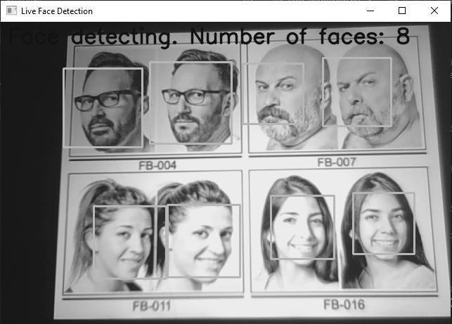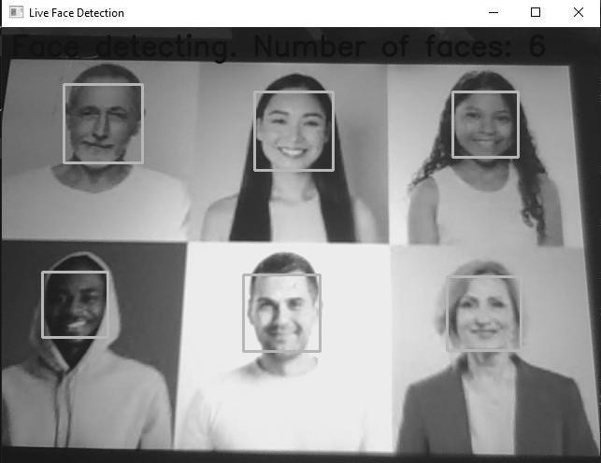

Output 1

Output 2